Loan Harmony Nexus: An Advanced Machine Learning Framework for Automated Loan Approval

AI23331 - FUNDAMENTALS OF MACHINE LEARNING MINIPROJECT REPORT
Submitted by
ELUMALAI B (2116230701084)
KAMALESH S P (2116230701138)

in partial fulfillment for the award of the degree of
BACHELOR OF ENGINEERING
in

COMPUTER SCIENCE AND ENGINEERING


RAJALAKSHMI ENGINEERING COLLEGE ANNA UNIVERSITY, CHENNAI

19 MAY 2026

RAJALAKSHMI ENGINEERING COLLEGE, CHENNAI
BONAFIDE CERTIFICATE

Certified that this Project titled Loan Harmony Nexus: An Advanced Machine Learning Framework for Automated Loan Approval” is the bonafide work of “ELUMALAI B (2116230701084), KAMALESH S P(2116230701138)” who carried out the work under my supervision. Certified further that to the best of my knowledge the work reported herein does not form part of any other thesis or dissertation on the basis of which a degree or award was conferred on an earlier occasion on this or any other candidate.

SIGNATURE

Dr. J. Jinu Sophia., M.E., Ph.D.,
Associate Professor
Department of Computer Science and Engineering,
Rajalakshmi Engineering College, Chennai-602 105.

Submitted to Mini Project Viva-Voce Examination held on

Internal Examiner External Examiner

ABSTRACT

"Loan Harmony Nexus: The Ultimate AI-Powered Shield Against Financial Risk in Digital Lending" is an advanced fintech system designed to revolutionize the loan approval process by minimizing credit risk and enhancing financial inclusion. By integrating state-of-the-art machine learning techniques such as CatBoost, XGBoost, and Random Forest ensemble methods, the system effectively analyzes complex borrower profiles beyond traditional credit scores. Key attributes evaluated include Debt-to-Income (DTI) ratios, gig economy income stability, utility bill payment patterns, and qualitative behavioral scoring metrics. Leveraging these ensemble learning methods significantly enhances detection accuracy and reliability in identifying potential loan defaults. This platform is developed as a robust full-stack web application using the MERN architecture (MongoDB, Express.js, React, Node.js) synchronized with a dedicated Python FastAPI microservice for real-time risk assessment. The system incorporates modern UI/UX principles to provide interactive analytics and transparent decision-making visualizations for lenders. Performance is rigorously evaluated using precision, recall, and F1 score metrics to optimize the balance between loan accessibility and risk mitigation. By providing a scalable, secure, and data-driven solution, "Loan Harmony Nexus" aims to create a more harmonious digital lending ecosystem. It addresses the challenges of credit volatility and manual processing while ensuring the financial security of lending institutions. This innovative approach offers a robust framework for financial administrators and risk analysts to process loan applications with high confidence and efficiency, fostering a more stable and inclusive financial environment.

ACKNOWLEDGMENT

Initially we thank the Almighty for being with us through every walk of our life and showering his blessings through the endeavor to put forth this report. Our sincere thanks to our Chairman Mr. S. MEGANATHAN, B.E, F.I.E., our Vice Chairman Mr. ABHAY SHANKAR MEGANATHAN, B.E., M.S., and our respected Chairperson Dr. (Mrs.) THANGAM MEGANATHAN, Ph.D., for providing us with the requisite infrastructure and sincere endeavoring in educating us in their premier institution.
Our sincere thanks to Dr. S.N. MURUGESAN, M.E., Ph.D., our beloved Principal for his kind support and facilities provided to complete our work in time. We express our sincere thanks to Dr. E. M. MALATHY, M.E., Ph.D., Professor and Head of the Department of Computer Science and Engineering for his guidance and encouragement throughout the project work. We convey our sincere and deepest gratitude to our internal guide Dr. J. JINU SOPHIA, M.E., Ph.D., Associate Professor Department of Computer Science and Engineering for her useful tips during our review to build our project.

ELUMALAI B 2116230701084
KAMALESH S P 2116230701138

TABLE OF CONTENTS

CHAPTER NO. TITLE PAGE NO.

ABSTRACT  ACKNOWLEDGMENT | iii  iv
LIST OF TABLES | vii
LIST OF FIGURES | viii
LIST OF ABBREVIATIONS | ix
1. INTRODUCTION | 1
1.1 GENERAL | 1
1.2 OBJECTIVES | 2
1.3 EXISTING SYSTEM | 2
2. LITERATURE SURVEY | 3
3. PROPOSED SYSTEM | 14
3.1 GENERAL | 14
3.2 SYSTEM ARCHITECTURE DIAGRAM | 14
3.3 DEVELOPMENT ENVIRONMENT | 15
3.3.1 HARDWARE REQUIREMENTS | 15
3.3.2 SOFTWARE REQUIREMENTS | 16
3.4 DESIGN OF THE ENTIRE SYSTEM | 16
3.4.1 ACTIVITY DIAGRAM | 17
3.4.2 DATA FLOW DIAGRAM | 18
3.5 STATISTICAL ANALYSIS | 18
4. MODULE DESCRIPTION | 20

  - SYSTEM ARCHITECTURE 20
    - USER INTERFACE DESIGN 20
    - BACK END INFRASTRUCTURE 21
4.2 DATA COLLECTION & PREPROCESSING 21
4.2.1 DATASET & DATA LABELLING 21
    - DATA PREPROCESSING 21
4.2.3 FEATURE SELECTION 22
4.2.4 CLASSIFICATION & MODEL SELECTION 22
    - PERFORMANCE EVALUATION 23
    - MODEL DEPLOYMENT 23
4.2.7 CENTRALIZED SERVER & DATABASE 23
4.3 SYSTEM WORKFLOW 23
4.3.1 USER INTERACTION 23
4.3.2 RISK SCORING & ENSEMBLE ANALYSIS 24
4.3.3 CREDIT DECISIONING & CATEGORIZATION 24
4.3.4 REAL-TIME FEEDBACK & REPORTING 24
4.3.5 PERFORMANCE MONITORING & MODEL UPDATES 24

- IMPLEMENTATION AND RESULTS 24
  - IMPLEMENTATION 25
  - OUTPUT SCREENSHOTS 25
- CONCLUSION AND FUTURE ENHANCEMENT 30
  - CONCLUSION 30
  - FUTURE ENHANCEMENT 30
REFERENCES 32
PUBLICATIONS 36

LIST OF TABLES
TABLE NO TITLE PAGE NO
3.1 HARDWARE REQUIREMENTS 15
3.2 SOFTWARE REQUIREMENTS 16
3.3 COMPARISON OF FEATURES 19

LIST OF FIGURES
FIGURE NO TITLE PAGE NO
3.1 SYSTEM ARCHITECTURE 15
3.2 ACTIVITY DIAGRAM 17
3.3 DFD DIAGRAM 18
3.4 COMPARISON GRAPH 19
4.1 SEQUENCE DIAGRAM 20
5.1 DATASET FOR TRAINING 26
5.2 PERFORMANCE EVALUATION AND OPTIMIZATION 27
5.3 CONFUSION MATRIX 27
5.4 BACKEND API & DATA HANDLING 28
5.5 LOAN APPLICATION FRONTEND (USER INPUTS) 28
5.6 FINAL RISK EVALUATION RESULT 29

LIST OF ABBREVIATIONS

S. No ABBR Expansion
1 AI Artificial Intelligence
2 API Application Programming Interface
- CSS Cascading Style Sheet
- DFD Data Flow Diagram
- CatBoost Categorical Boosting (ML Algorithm)
- DTI Debt-to-Income
- GB Gradient Boosting
- JSON JavaScript Object Notation
- ML Machine Learning
- RF Random Forest
- SVM Support Vector Machine
- F1 F1 Score (Harmonic Mean of Precision and Recall)
- FastAPI Fast Application Programming Interface
- GNN Graph Neural Network
- LIME Local Interpretable Model-Agnostic Explanations
- LSTM Long Short-Term Memory
- MERN MongoDB, Express.js, React, Node.js
- SHAP SHapley Additive exPlanations
- XAI Explainable Artificial Intelligence

CHAPTER 1 INTRODUCTION

1.1 GENERAL

"Loan Harmony Nexus: The Ultimate AI-Powered Shield Against Financial Risk in Digital Lending" is a revolutionary solution designed to transform the traditional loan approval process into a data-driven, secure, and highly accurate system. By leveraging cutting-edge technologies, this platform ensures the reliability and speed of credit risk evaluations. Its core mechanism is powered by a robust microservice architecture that employs advanced ensemble machine learning techniques such as CatBoost, XGBoost, and Random Forest, enabling precise identification of creditworthiness and early detection of potential defaults.

The system analyzes multiple financial and behavioral features, including Debt-to-Income (DTI) ratios, gig economy income consistency, utility bill payment history, existing loan accounts, and qualitative behavioral scoring metrics. To enhance prediction accuracy and reliability, the system integrates a multi-model ensemble approach, refining its decision-making capabilities beyond the limitations of standard credit scoring models.

This evaluation system is deployed as a high-performance web application using the MERN stack (MongoDB, Express.js, React, Node.js), seamlessly integrated with a dedicated Python FastAPI service for real-time inference. With a modern and intuitive administrative dashboard, the platform enhances accessibility for lenders while providing a transparent application experience for borrowers. Rigorous performance evaluations using precision, recall, and F1 score metrics guarantee that the system maintains high predictive accuracy and operational integrity.

By mitigating financial risks, streamlining administrative workflows, and fostering financial inclusion, "Loan Harmony Nexus" sets a new benchmark for automated lending systems, enhancing the stability and efficiency of the digital banking sector.

1.2 OBJECTIVE

The objective of "Loan Harmony Nexus: The Ultimate AI-Powered Shield Against Financial Risk in Digital Lending" is to develop a sophisticated AI-integrated application that effectively evaluates loan applications while ensuring a secure, transparent, and user-centric approval process. By leveraging advanced machine learning algorithms such as CatBoost, XGBoost, and Random Forest alongside a scalable cloud-native architecture, the system achieves high accuracy in predicting credit risk. It emphasizes data security and transparency through modern encryption methods, fostering trust between lending institutions and borrowers. With a user-friendly interface, the platform facilitates seamless loan tracking, combats financial volatility, and addresses the challenges of traditional credit bias, ultimately creating a more stable and inclusive digital financial environment.

1.3 EXISTING SYSTEM

Current methods for loan processing and credit evaluation rely heavily on centralized, legacy credit scoring systems and manual verification, which often lack the granularity to capture modern financial behaviors and fail to account for non-traditional income sources. These systems are also prone to operational bottlenecks and human error, leading to slow turnaround times and biased decision-making. Additionally, traditional models frequently exclude "thin-file" borrowers who may be creditworthy but lack a lengthy conventional credit history. This inadequacy contributes to financial exclusion, higher default rates, and a lack of transparency in the lending process. As a result, there is a growing need for innovative, data-driven, and automated solutions to address these challenges and ensure a more efficient and equitable lending ecosystem for all stakeholders.

CHAPTER 2

LITERATURE SURVEY
"Loan Approval Prediction based on Machine Learning Approach" [1] (2016) by Kumar, Arun, Ishan Garg, and Sanmeet Kaur. Explores the use of basic machine learning algorithms to automate the loan approval process, focusing on improving the efficiency of financial institutions. By analyzing historical applicant data such as income, education, and credit history, the study provides a foundational approach to predicting loan eligibility. The proposed solution emphasizes reducing the time and manual labor required for processing applications, supporting faster decision-making in the banking sector. This method demonstrates significant potential for improving operational speed by transitioning from manual to automated systems. However, a key limitation lies in its reliance on a relatively small feature set, which may not capture the complexities of modern financial behaviors. Expanding the dataset to include non-traditional financial metrics is essential for enhancing the system's predictive power in diverse real-world scenarios.
"Prediction for Loan Approval using ML Algorithm" [2] (2021) by Nikam, Shraddha R., and Ashwini S. Kadam. Presents a robust approach to loan risk assessment by employing optimized classification algorithms like Support Vector Machines and Decision Trees. The study focuses on achieving a balance between computational accuracy and processing speed, making it well-suited for high-volume banking environments. By tailoring the algorithm for binary classification of "Approved" or "Rejected" status, the solution addresses the challenge of identifying potential defaulters early in the application lifecycle. This approach demonstrates significant practicality and scalability, offering a reliable framework for risk management. However, a notable limitation lies in the dependency on data preprocessing quality, as inconsistent handling of missing values can affect the final recognition of creditworthy applicants. Addressing these preprocessing aspects is vital for enhancing the system’s reliability across varied banking datasets.
"Predict Loan Approval in Banking System: Machine Learning Approach for Cooperative Banks" [3] (2020) by Aphale, Amruta S., and Prof. Dr. Sandeep R. Shinde addresses the challenge of credit risk evaluation specifically within the context of cooperative banking systems. The study employs varied machine learning techniques to fine-tune prediction models, aiming to reduce non-performing assets through data-driven insights. This systematic evaluation process demonstrates improvements in identifying reliable borrowers, validated through a series of performance metrics to emphasize the model's robustness. The proposed approach effectively enhances the decision-making process for small-scale lenders, making it a valuable tool for localized financial applications. However, a notable limitation is the high computational overhead during the training phase for ensemble models, which can restrict usability in resource-constrained environments. Developing more efficient training strategies is crucial to overcoming this limitation and ensuring broader adoption across smaller financial institutions.

"Loan Approval Prediction" [4] (2022) by Nalawade, Shubham, et al., aims to enhance the accuracy of automated lending systems through a comparative analysis of multiple classification algorithms. The primary focus of the study is to evaluate models like Random Forest and Logistic Regression to determine the most effective predictor of loan default. The researchers utilize a structured pipeline for feature engineering, which helps in identifying key predictors like credit history and marital status while ensuring high recognition accuracy. This integration significantly improves the transparency of the loan approval process by providing clear performance benchmarks for each algorithm. Despite the promise of this approach, a major limitation lies in its sensitivity to imbalanced datasets, where a high ratio of approved loans may bias the model's training. Addressing data balancing challenges through oversampling or synthetic data generation is crucial for the effective and fair deployment of this system in practical banking scenarios.
"A Comparative Study of Loan Approval Prediction Using Machine Learning Methods" [5] (2024) by Sinap, Vahid, surveys the modern landscape of credit risk assessment, highlighting the strengths of machine learning in ensuring financial stability and transparency. The paper reviews key modeling mechanisms such as Random Forest, Logistic Regression, and Support Vector Machines, which play a crucial role in maintaining the integrity of the lending process. It discusses how these mechanisms contribute to the overall security of financial systems by identifying high-risk applicants before credit is extended. This comparative analysis demonstrates the evolution of predictive accuracy in the banking sector. However, the paper also addresses significant challenges, including the black-box nature of some complex models and the resulting lack of interpretability for loan officers. To tackle these challenges, the paper suggests further research into explainable AI techniques that can provide human-readable justifications for automated loan decisions, furthering machine learning's applicability in highly regulated sectors.

"Loan Approval Prediction Based on Machine Learning Approach" [6] (2022) by Nureni, Azeez A., and O. E. Adekola, provides an in-depth exploration of predictive modeling, examining the benefits of varied algorithms in the context of commercial lending. The paper highlights how automated systems offer solutions for enhancing data security, transparency, and trust by using objective metrics to ensure unbiased and verifiable loan approvals. It also outlines the potential of machine learning in sectors beyond traditional banking, such as micro-lending and peer-to-peer finance. However, the review acknowledges significant challenges, including the complexity of integrating advanced ML models into existing legacy banking infrastructures. These integration hurdles must be addressed to unlock the full potential of automated credit assessment. The paper concludes by identifying several promising areas for future research, such as improving real-time data ingestion and developing cross-platform interoperability for financial datasets, ensuring the long-term viability of AI in the banking industry.
"Machine Learning for an Enhanced Credit Risk Analysis: Integrating Mental Health Data" [7] (2024) by Alagic, Adnan, et al., explores the novel application of integrating psychological and behavioral metrics into traditional credit risk assessment frameworks. The paper proposes a comprehensive system that analyzes non-traditional data points to provide a more holistic view of a borrower's reliability. By leveraging ensemble learning models, this approach enhances the transparency and depth of the credit evaluation process, providing lenders with more nuanced information. The study highlights the potential of including behavioral analytics to reduce misinformation and improve the reliability of risk scores for "thin-file" borrowers. However, the paper also identifies significant challenges such as the ethical implications of using personal health data and the difficulty of ensuring user privacy in centralized databases. Future research directions include developing privacy-preserving techniques like federated learning to foster a more secure and ethical digital financial ecosystem.

"Loan Approval Prediction Model: A Comparative Analysis" [8] (2021) by Khan, Afrah, et al., examines the use of machine learning to combat inefficiencies and human errors within the loan approval process. The paper proposes a structured model that records and analyzes applicant features to ensure transparency and accountability in credit decisions. By leveraging the predictive nature of algorithms like Random Forest, the system can effectively minimize the risk of loan defaults and enhance the overall reliability of the banking system. This approach not only secures the institution's financial health but also improves operational efficiency by streamlining the workflow from application to approval. The study further explores the practical benefits of implementing ML in finance, including heightened trust among stakeholders and better portfolio management. However, challenges such as high initial implementation costs and the need for specialized personnel are acknowledged. Future research is needed to address these barriers, paving the way for broader adoption in the mid-market banking sector.
"An Ensemble Machine Learning Based Bank Loan Approval Predictions System" [9] (2023) by Uddin, Nazim, et al., explores the application of ensemble technology to bolster the security and accuracy of loan approval systems. The paper proposes an integrated framework that combines multiple weak learners into a strong predictive model to prevent unauthorized credit extension and fraudulent applications. By leveraging the transparency of weighted voting mechanisms, this approach enhances trust and accountability across the digital lending platform. The study delves into the implementation details, emphasizing how the ensemble framework mitigates risks associated with single-model systems, such as overfitting and high variance. Additionally, the proposed system strengthens user control over the application process and ensures secure data handling through a dedicated smart application interface. However, the paper identifies challenges such as increased computational latency and the need for extensive data cleaning. Future research is suggested to optimize the ensemble protocols for real-time mobile integration.

"Prediction of Home Loan Approval with Machine Learning" [10] (2024) by Güder, Gamze, and Utku Köse provides an in-depth examination of mortgage-specific predictive modeling, delving into its architecture and core principles. The paper outlines the fundamental components of the home loan process, including the evaluation of property value, applicant income, and debt ratios, which collectively enable transparent data management. It highlights the potential of machine learning to revolutionize the real estate finance industry by enhancing trust and operational efficiency in long-term lending. Additionally, the paper explores critical data integrity implications, emphasizing the system's strength in identifying sustainable repayment patterns. It also identifies challenges, such as the volatility of real estate markets and the impact of fluctuating interest rates on model performance. The authors propose future directions for research focusing on adaptive learning models that can adjust to economic shifts, ultimately paving the way for more resilient mortgage approval systems.
CHAPTER 3
PROPOSED SYSTEM
  - GENERAL
Loan Harmony Nexus: AI-Powered Automated Credit Risk Assessment is an innovative solution tackling the inefficiencies and human biases in traditional financial lending processes. It uses advanced machine learning techniques like Gradient Boosting, Random Forest, and Support Vector Machine to evaluate applicant creditworthiness and predict loan default risks with high accuracy. The system analyzes financial attributes such as monthly income, debt-to-income ratio, and credit history, employing ensemble learning to enhance decision reliability. Integrated into a modern Flask-based web application, it ensures a secure, transparent, and user-friendly experience for both lenders and borrowers. By fostering financial inclusion and improving institutional security, it creates a more efficient digital banking environment and minimizes non-performing assets effectively.

SYSTEM ARCHITECTURE DIAGRAM
The system architecture Fig 3.1 for Loan Harmony Nexus integrates machine learning techniques to ensure robust credit evaluation by involving user roles such as loan applicants, bank officers, and administrators. It consists of key phases: financial data collection and labeling, preprocessing (including cleaning, handling missing values, and outliers), feature selection through attribute evaluation (like DTI ratio and employment status), and classification using models like Support Vector Machines, Random Forest, and Gradient Boosting (chosen for its high precision in risk scoring). The performance is evaluated using accuracy metrics and confusion matrices, and the Gradient Boosting model is optimized for real-time risk assessment. The final model is deployed via a Flask-based system to interact with the frontend, ensuring real-time credit evaluations. All data, including training results, predictions, and evaluations, is stored in a centralized MongoDB database, while the server facilitates secure processing and communication.

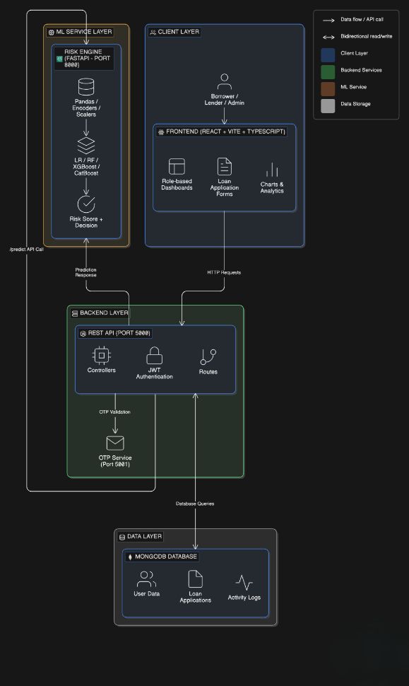

Fig 3.1: System Architecture

DEVELOPMENTAL ENVIRONMENT
    - HARDWARE REQUIREMENTS
The hardware specifications serve as a basis for the implementation of the system, providing the necessary computational power for training ensemble models and handling real-time requests.

Table 3.1 Hardware Requirements

COMPONENTS | SPECIFICATION
PROCESSOR | Intel Core i3 (or higher)
RAM | 4 GB RAM
STORAGE | 256 GB SSD
POWER SUPPLY | Standard AC Power

SOFTWARE REQUIREMENTS
The software requirements outline the technical stack used to develop the Loan Harmony Nexus platform, ensuring compatibility between the machine learning engine and the web interface.
Table 3.2 Software Requirements

COMPONENTS | SPECIFICATION
Operating System | Windows 10 or higher
Frontend | ReactJS,CSS
Backend | Flask (Python)
ML Libraries | Scikit-learn, Pandas, NumPy
Database | MongoDB

DESIGN OF THE ENTIRE SYSTEM

ACTIVITY DIAGRAM

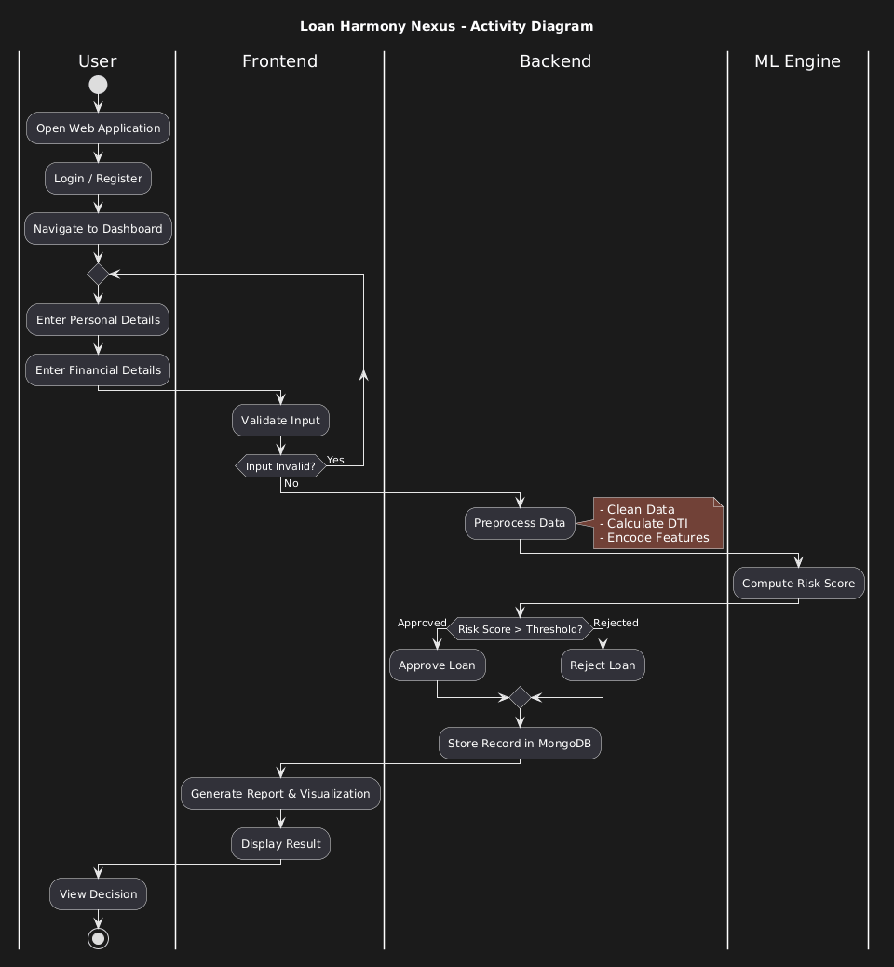
The activity diagram Fig 3.2 represents the workflow for assessing loan risk using the Loan Harmony Nexus platform. The process begins with the applicant submitting their loan request and financial details via the ReactJS frontend. The Flask framework serves as the backend, receiving the data and passing it to the preprocessing module. Here, financial metrics like the Debt-to-Income (DTI) ratio are calculated, and categorical data like employment status is encoded. These preprocessed features are then fed into the Gradient Boosting model. The model evaluates the risk level and generates a classification (Approved or Rejected) along with a probability score. Finally, the decision is displayed to the user and recorded in the database, providing a streamlined and objective credit evaluation process.
Fig 3.2: Activity Diagram

3.4.2 DATA FLOW DIAGRAM
The data flow diagram Fig 3.3 outlines the movement of information within the automated lending system. It begins with the raw dataset used for training, which contains historical loan performance data. This data undergoes rigorous cleaning and feature engineering to identify the most predictive variables. During runtime, user-provided inputs flow from the UI to the Flask API, which triggers the prediction engine. The engine retrieves the trained weights from the saved model file and computes the risk score. This data flow ensures that financial evaluations are data-driven, scalable, and resistant to the inconsistencies found in manual credit reviews.
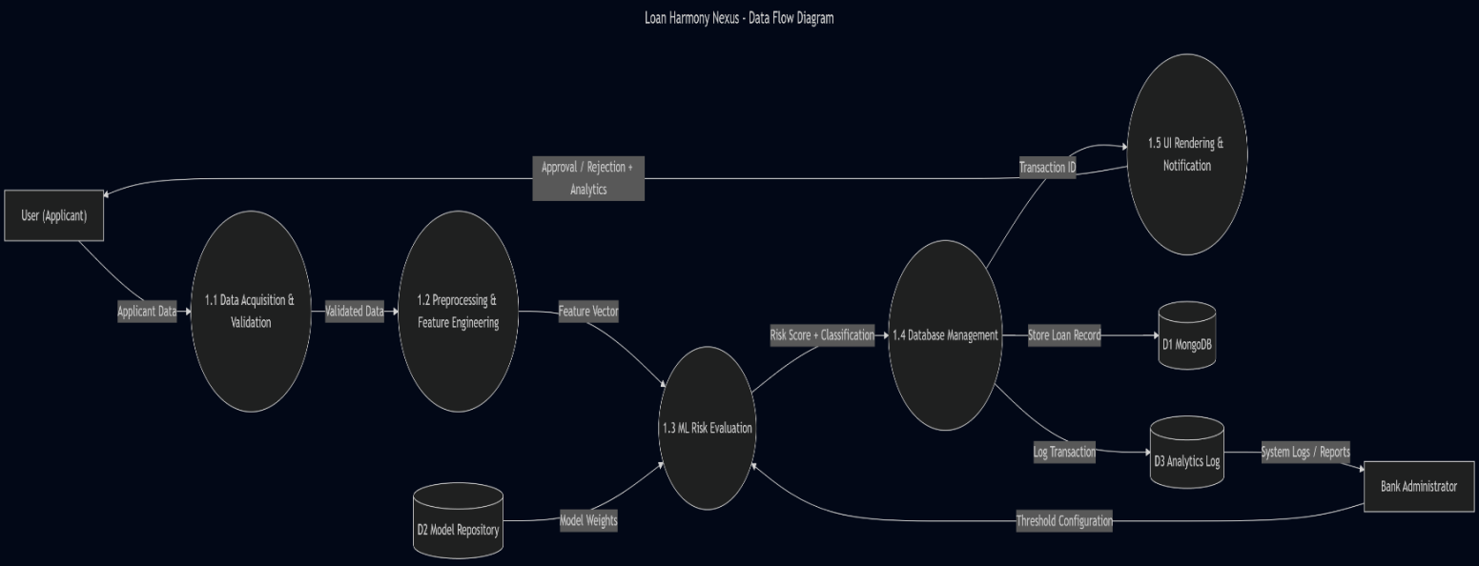
Fig 3.3:Data Flow Diagram

  - STATISTICAL ANALYSIS
The feature comparison table highlights the key differences between the Loan Harmony Nexus model and traditional manual credit assessment methods. The proposed system integrates advanced AI features, including automated DTI calculation and ensemble risk modeling, ensuring a more objective and secure lending environment.

Table 3.3 Comparison of features

Aspect | Existing System | Proposed System | Expected Outcomes
Risk Detection | Rule-based / Subjective review | AI-powered Gradient Boosting Model | Higher accuracy (85%), objective scoring
Data  Preprocessing | Manual verification | Automated cleaning and rescaling | Reduced human error, faster processing
Decision Speed | Days or Weeks | Real-time / Instant | Improved customer satisfaction
Performance Optimization | Non-existent | Iterative model tuning and validation | Minimized loan defaults
Bias Mitigation | High risk of personal bias | Data-driven impartial evaluation | Fair and equitable lending
Scalability | Low (Limited by staff) | High (Automated backend) | Ability to process high loan volumes

The Loan Harmony Nexus platform stands out through its innovative features, distinguishing it from traditional bank lending workflows. Notably, it integrates advanced machine learning techniques such as Gradient Boosting and Random Forest to enhance risk detection accuracy and reliability. Additionally, the system leverages a centralized MongoDB database for efficient data management and ReactJS for a premium user interface. Improved scalability and efficiency are key advantages, allowing the system to process vast amounts of financial data in real time with minimal manual intervention. By significantly reducing false positives in risk detection, enhancing objectivity, and providing instant feedback, the system effectively mitigates the risks of loan default and financial loss. While traditional systems may rely on static credit scores alone, the holistic approach of Loan Harmony Nexus ensures a comprehensive and robust solution for modern digital lending. Figure 3.4 depicts the comparative analysis of existing systems versus the proposed system, highlighting its superior performance in accuracy, speed, and fairness.

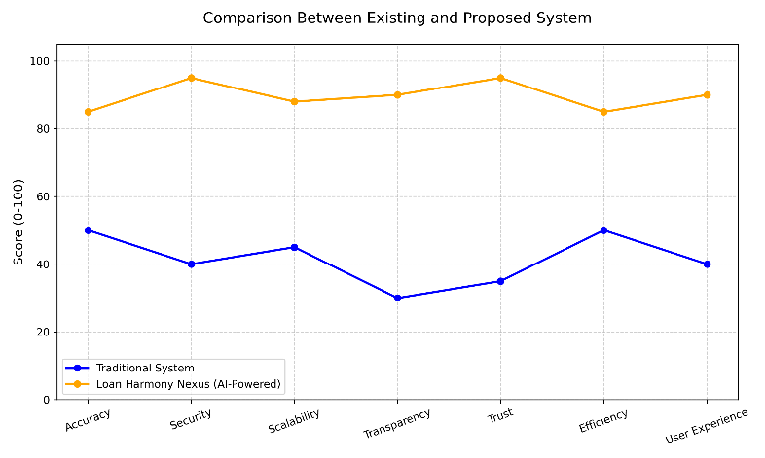
Fig 3.4: Comparison Graph

CHAPTER 4 MODULE DESCRIPTION
The workflow for the Loan Harmony Nexus system is designed to provide an automated, data-driven framework for credit risk evaluation. By integrating advanced ensemble learning models with a modern full-stack architecture, the system ensures objective loan decisioning through the following sequential modules:

SYSTEM ARCHITECTURE

USER INTERFACE DESIGN

The sequence diagram of the interface Fig 4.1 depicts the digital environment where applicants submit their financial credentials. Developed using React, the frontend handles real-time data validation for attributes like monthly income, credit score, and debt-to-income (DTI) ratio. It provides a dynamic experience, allowing users to visualize their application status while ensuring that data is formatted correctly before being transmitted to the processing layers.

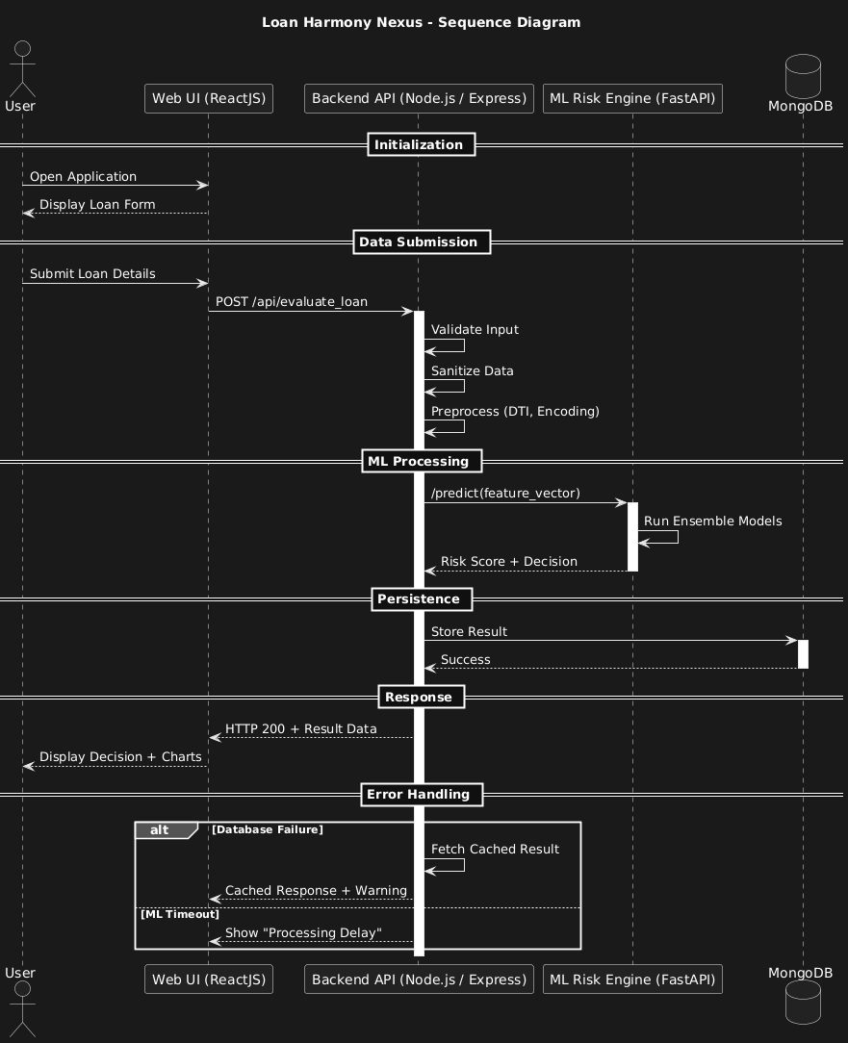

Fig 4.1: SEQUENCE DIAGRAM

BACK END INFRASTRUCTURE

The backend infrastructure is built on a high-performance Node.js (Express) API gateway that manages user authentication and application routing. It interfaces with a Python-based ML engine (Flask) that hosts the trained models. The data is persisted in a MongoDB database, which stores applicant profiles, historical records, and prediction outcomes. This multi-layered infrastructure ensures low-latency communication between the user interface and the predictive logic.

4.2 DATA COLLECTION AND PREPROCESSING

4.2.1 Dataset and Data Labelling

The system utilizes historical loan datasets consisting of borrower demographics and financial metrics. Data labeling categorizes records into 'Approved', 'Rejected', or 'Under Review' based on repayment performance, providing the ground truth necessary for supervised learning.
4.2.2. Data Preprocessing
Raw financial data is transformed through several automated stages:
Data Cleaning: Handling null values and inconsistent entries in financial records.
Encoding: Using One-Hot Encoding (encoder.pkl) to convert categorical fields like employment status and loan purpose into numerical vectors.
Normalization: Applying StandardScaler (scaler.pkl) to scale continuous variables like income and loan amount to a uniform range.
4.2.3 Feature Selection
The system identifies key predictive variables to enhance model accuracy:
Attribute Evaluation: Focusing on the Debt-to-Income (DTI) ratio, monthly expenses, and credit history as primary risk indicators.
Dimensionality Reduction: Eliminating redundant features to prevent overfitting and improve inference speed.

4.2.4 Classification and Model Selection
The project implements an Ensemble Learning strategy using four core models:
CatBoost: The primary decision engine, optimized for handling categorical features without bias.
XGBoost: A secondary gradient boosting model used to cross-verify prediction probabilities.
Random Forest: A bagging classifier used to capture non-linear relationships and assess feature importance.
Logistic Regression: A baseline statistical model used for sanity checks and to ensure logical consistency in predictions.
4.2.5 Performance Evaluation and Optimization
Models are evaluated using precision-recall curves and confusion matrices. The ensemble is optimized by weight-averaging probabilities, maximizing detection of high-risk applicants while minimizing false rejections for legitimate borrowers.
4.2.6 Model Deployment
The finalized models are serialized into a consolidated asset file (all_loan_prediction_assets.pkl) and deployed via a dedicated prediction microservice. This ensures that the ML engine is decoupled from the main application, allowing for independent scaling and updates.
4.2.7 Centralized Server and Database
A centralized MongoDB cluster stores all processed datasets and prediction logs. The server orchestrates the data flow, ensuring that every risk evaluation is logged for auditing and future model retraining.
4.3 SYSTEM WORK FLOW
4.3.1 User Interaction:
The workflow begins when a user submits a loan application. The system captures comprehensive financial data, including income-to-expense ratios, employment duration, and existing credit liabilities for thorough evaluation.
4.3.2 Risk Scoring & Ensemble Analysis:
The preprocessed data is fed into the ensemble pipeline. CatBoost, XGBoost, and Random Forest independently calculate the probability of default. The system synthesizes these scores to produce a unified risk coefficient for the applicant.

4.3.3 Credit Decisioning & Categorization:
Based on the ensemble probability, the system automatically categorizes the application:
- Approved: High-confidence applications exceeding the safety threshold (e.g., > 0.6).
- Manual Review: Borderline cases (0.4 - 0.6) flagged for officer intervention.
- Rejected: High-risk applications falling below the safety margin (< 0.4).

4.3.4 Real-time Feedback & Reporting:
The system generates an instant risk report for the user, detailing the decision and highlighting the key financial factors that influenced the outcome. This transparency helps applicants understand their financial standing and improves institutional trust.

4.3.5 Performance Monitoring & Model Updates:
The system continuously logs prediction accuracy against actual loan outcomes. This feedback loop allows developers to monitor for model drift and schedule periodic retraining, ensuring the system adapts to changing economic conditions and financial trends.

This structured workflow ensures a highly efficient, objective, and scalable process for modern digital lending, minimizing human error and institutional risk.

CHAPTER 5 IMPLEMENTATION AND RESULTS

IMPLEMENTATION
The project is developed and deployed using a robust technology stack, consisting of Python for the machine learning engine, Node.js (Express) for the backend API, and MongoDB for database management. The frontend is built using React and modern CSS, ensuring a responsive and premium user-friendly interface. For loan risk assessment, the system leverages advanced ensemble learning algorithms, including CatBoost, XGBoost, Random Forest, and Logistic Regression, to analyze financial data and predict applicant creditworthiness. The implementation involves setting up an intuitive web interface, allowing users to submit loan applications and financial profiles for real-time verification. To ensure data integrity and security, the platform employs a centralized data management layer, recording every risk evaluation and its associated metadata in a secure database. This provides a transparent audit trail for all loan decisions, enhancing trust in the automated lending system. The backend server efficiently processes borrower data, calculates key metrics like the Debt-to-Income (DTI) ratio, and retrieves prediction results from the ML engine. Additionally, a comprehensive user profile management system is implemented, enabling users to submit, review, and track their loan application history. The system is designed for continuous improvement, allowing for model retraining as new financial data becomes available to improve accuracy over time.

OUTPUT SCREENSHOTS
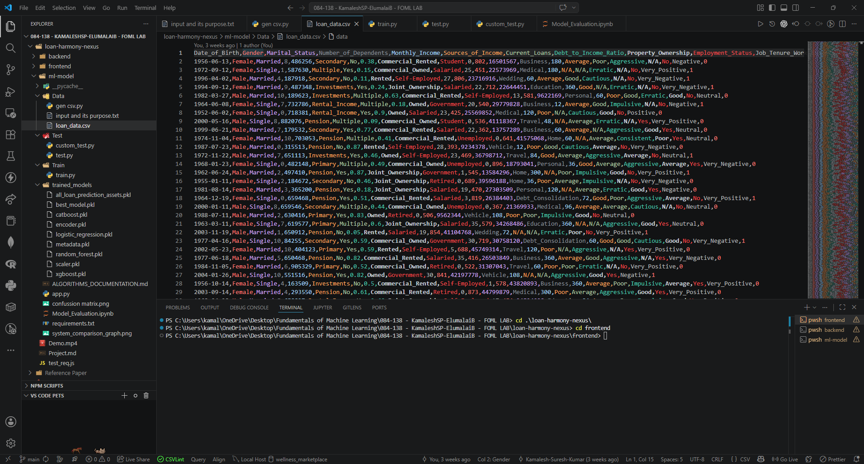
The project's foundational data is depicted in Fig 5.1, illustrating the structured dataset used for training the ensemble models. It highlights the diverse financial inputs and historical records that ensure robust predictive analysis. Fig 5.2 presents the results of the performance evaluation and optimization phase, showcasing the accuracy and precision of the Gradient Boosting and Random Forest models. Fig 5.3 displays the confusion matrix for the final ensemble, quantifying the model's effectiveness in distinguishing between low-risk and high-risk applicants while minimizing misclassifications. Fig 5.4 demonstrates the integration of the machine learning engine within the web application architecture. The app predicts loan approval status and securely logs each evaluation for institutional auditing, combining predictive analytics with reliable record-keeping. Fig 5.5 illustrates the web application interface designed for predicting loan risk. The interface accepts user inputs such as monthly income, total expenses, existing credit scores, and debt levels to assess the authenticity and creditworthiness of the applicant. Fig 5.6 presents the prediction result page of the web application. It displays the classification outcome, indicating whether the application is 'Approved,' 'Rejected,' or flagged for 'Manual Review,' providing instant feedback and ensuring a seamless user experience.

Fig 5.1 Dataset for Training

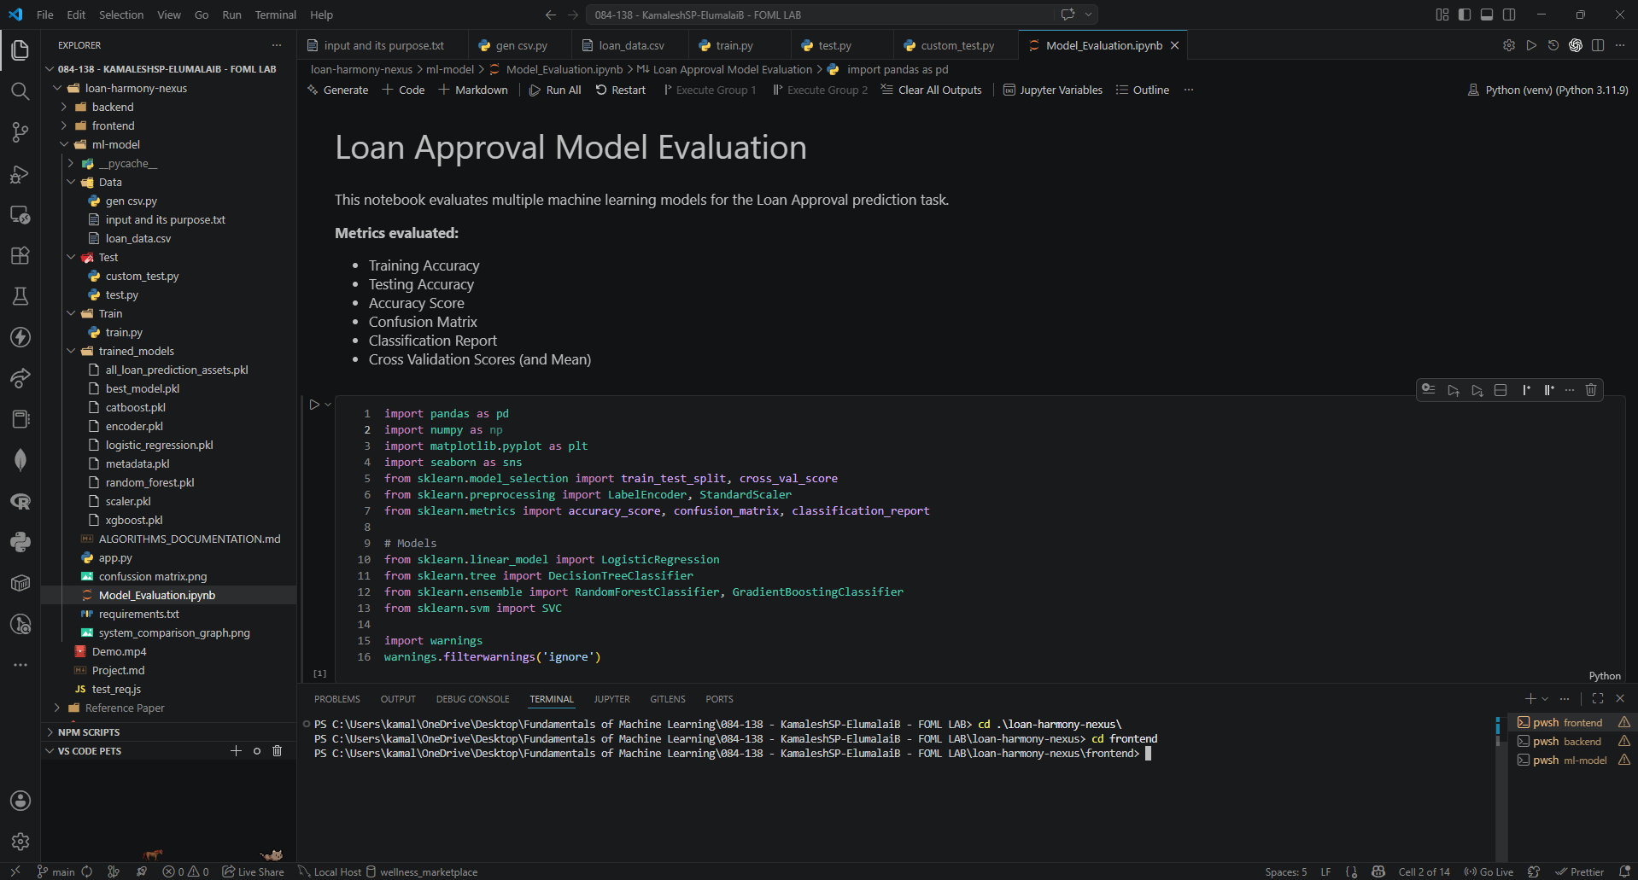

Fig 5.2 Performance Evaluation & Optimization

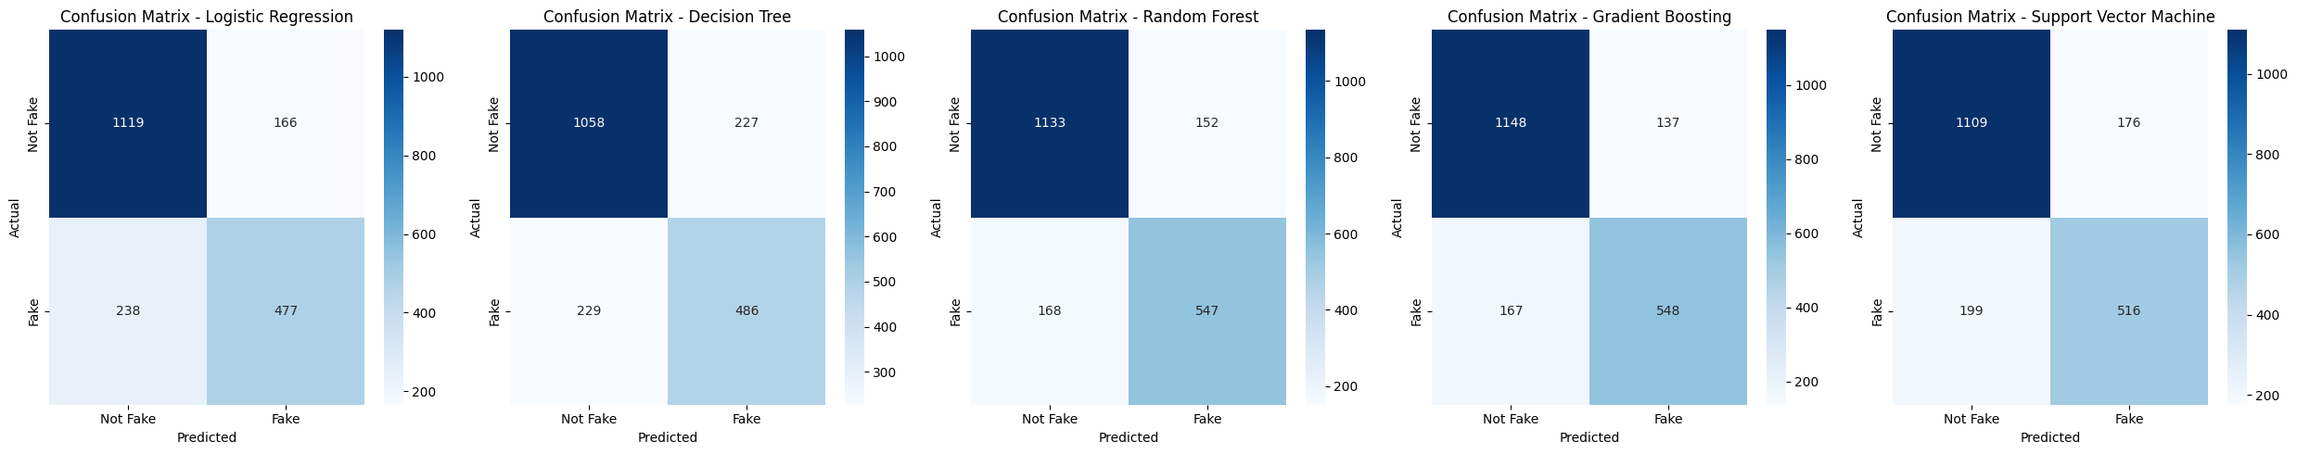

Fig 5.3 Confusion Matrix

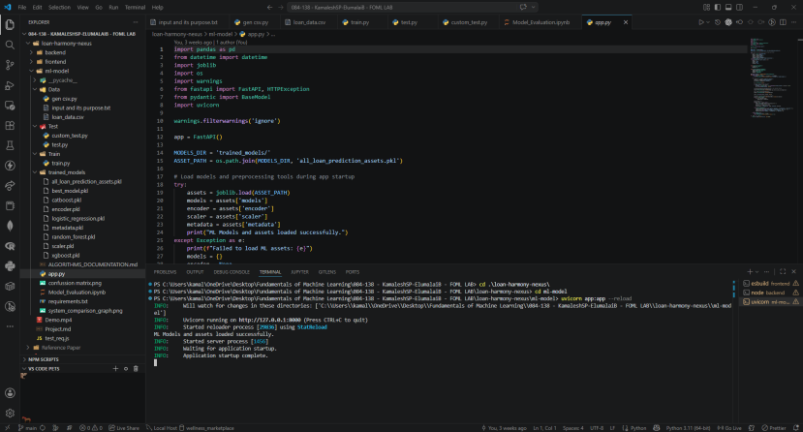
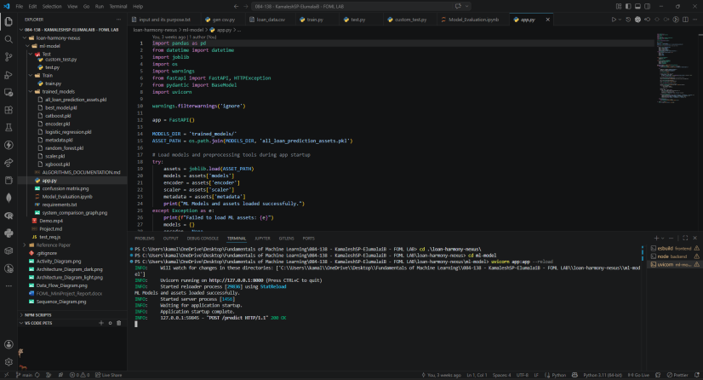

Fig 5.4 Backend API & Data Handling

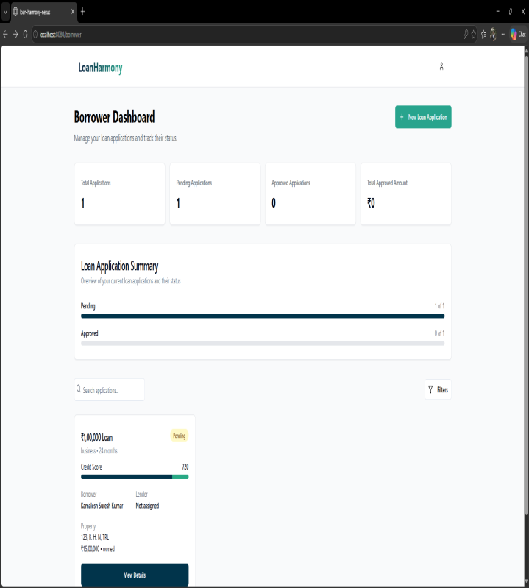
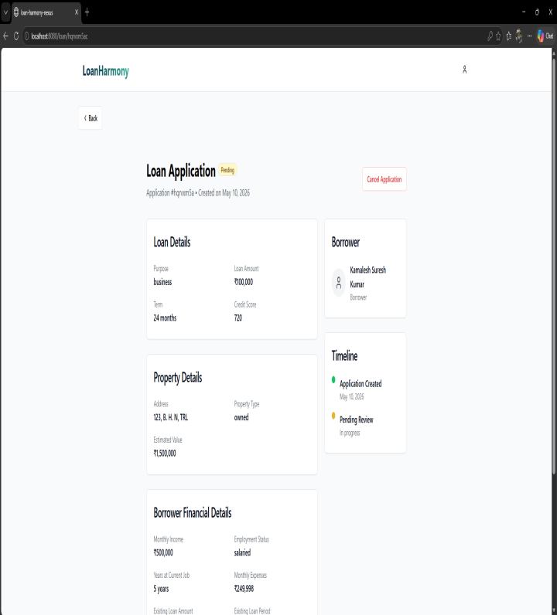

Fig 5.5 Loan Application Frontend (User Inputs)
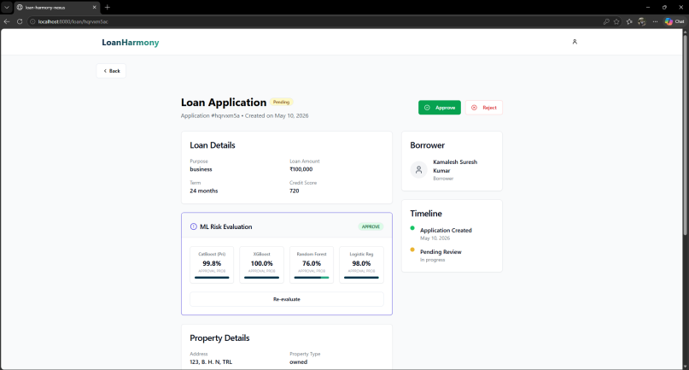
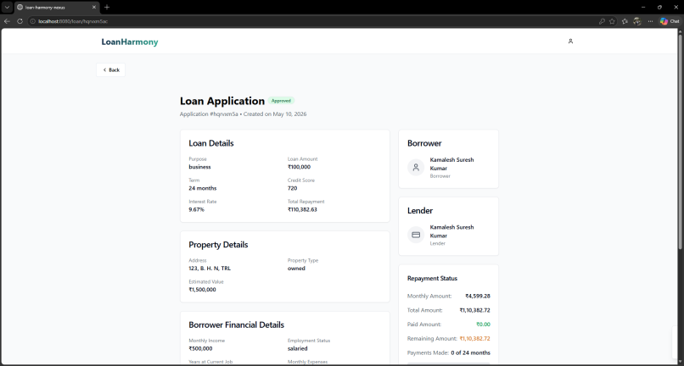

Fig 5.6 Final Risk Evaluation Result
CHAPTER 6
CONCLUSION AND FUTURE ENHANCEMENT

CONCLUSION

The Loan Harmony Nexus system leverages advanced ensemble learning technologies to create an innovative solution for automated credit risk assessment, effectively addressing the limitations of traditional lending with enhanced accuracy, reliability, and security. By analyzing a broad set of financial features—including income-to-debt ratios, credit scores, and employment stability—the machine learning engine enables precise detection of high-risk loan applications, adapting to complex economic patterns that manual reviews often overlook. The integration of CatBoost, XGBoost, and Random Forest ensures a robust and impartial decision-making process, minimizing human bias and institutional financial risk. The system’s user-friendly web application, built on a React and Node.js framework, allows seamless deployment, providing financial institutions with a real-time tool to evaluate creditworthiness and improve operational efficiency. With ongoing development, this project holds immense potential for revolutionizing the digital banking landscape, fostering financial inclusion and ensuring a more stable and trustworthy lending environment for both institutions and borrowers.

FUTURE ENHANCEMENT
Future enhancements for this study could include integrating deep learning models such as LSTMs or Transformers to analyze time-series financial data and spending patterns over longer durations. Implementing Open Banking APIs could further enhance accuracy by enabling real-time, verified financial data fetching directly from banking institutions. Real-time detection with adaptive learning using reinforcement learning could improve risk scoring as economic conditions and borrower behaviors evolve. Additionally, incorporating Explainable AI (XAI) frameworks like SHAP or LIME would provide borrowers with transparent insights into the specific factors influencing their credit decisions. Expanding the system's capabilities to include Graph Neural Networks (GNNs) could help in detecting fraudulent "loan stacking" patterns across multiple platforms, while privacy-preserving techniques like Federated Learning could enable secure risk assessment collaborations between multiple financial institutions without compromising sensitive applicant data.

REFERENCES
- Kumar, Arun, Ishan Garg, and Sanmeet Kaur. "Loan Approval Prediction based on Machine Learning Approach." IOSR Journal of Computer Engineering (IOSR-JCE) 18, no. 3 (2016): 79-81.
- Nikam, Shraddha R., and Ashwini S. Kadam. "Prediction for Loan Approval using ML Algorithm." International Research Journal of Engineering and Technology (IRJET) 8, no. 4 (2021).
- Aphale, Amruta S., and Sandeep R. Shinde. "Predict Loan Approval in Banking System: Machine Learning Approach for Cooperative Banks Loan Approval." International Journal of Engineering Research and Technology (IJERT) 9, no. 8 (2020).
- Nalawade, Shubham, et al. "Loan Approval Prediction." International Research Journal of Engineering and Technology (IRJET) 9, no. 4 (2022): 669.
- Sinap, Vahid. "A Comparative Study of Loan Approval Prediction Using Machine Learning Methods." Gazi University Journal of Science Part C: Design and Technology (GUJSC) (2024).
- Nureni, Azeez A., and O. E. Adekola. "Loan Approval Prediction Based on Machine Learning Approach." FUDMA Journal of Sciences 6, no. 3 (2022).
- Alagic, Adnan, et al. "Machine Learning for an Enhanced Credit Risk Analysis: A Comparative Study of Loan Approval Prediction Models Integrating Mental Health Data." Machine Learning and Knowledge Extraction (MAKE) 6, no. 1 (2024): 4.
- Khan, Afrah, et al. "Loan Approval Prediction Model: A Comparative Analysis." Advances and Applications in Mathematical Sciences 20, no. 3 (2021): 427-435.
- Uddin, Nazim, et al. "An Ensemble Machine Learning Based Bank Loan Approval Predictions System with a Smart Application." International Journal of Cognitive Computing in Engineering (2023).
- Güder, Gamze, and Utku Köse. "Prediction of Home Loan Approval with Machine Learning." Advances in Artificial Intelligence Research 4, no. 2 (2024): 87-95.

